September Spelling Contract
Your goal is to earn points that will go towards classroom coupons. Some activities are worth one point each, while some are worth two points. You must complete one activity per night Monday-Thursday. You also need to complete AT LEAST ONE activity worth two points. Please color in the boxes you have completed, as well as a parent signature for EACH activity completed. Your parent can sign in each box you choose to do. Have fun earning your points. All activities are due on Friday. If your work is completed on paper, complete in homework notebook.
One Point Activity
Back to School Scene  Draw a picture of a back to school scene and hide your spelling words in your drawing! Don’t forget to make it colorful and detailed. | Scrambled Words  Have an adult scramble up your spelling words and then you have to try and put the letters in the correct order.  Example:  ylap = play | Be the Teacher  Give an adult, babysitter, or older sibling a spelling test. Then, carefully grade their answers.
Word Sort  Find a way to sort your words. You can sort your words by spelling pattern, number of letters, number of vowels, etc. You must use all of your spelling words. | Type ‘Em Up  Type each of your spelling words on the computer. Change the font for each word. | Neon Words  Write each of your spelling words neatly. Then highlight all the vowels with a highlighter. Then highlight all of the consonants with a different colored highlighter.
Spelling City  Visit www.spellingcity.com/jcacaccio/.  Click on the current week’s list. The choose one of the activities to practice your spelling words. | Count It Out  Write each of your words neatly and then divide each word into syllables. You may use a dictionary to help you.  Example:  Scarecrow scare/crow | Bouncing Words  Say your spelling word. Then bounce a ball while you spell it out loud. Bounce the ball once per letter. Once you have spelled the word, say the word again. Repeat for all your words.

Two Point Activities

Broadcaster Spelling  Pretend you are a news anchor, weather person, or reporter and use your spelling words to write a news report. You may also write multiple news reports that only use some of your words until you have used all of your spelling words in a news story. | Comic Strip Spelling  Use your spelling words to write and illustrate a comic strip. You may use all your spelling words in one comic strip or you may write and illustrate multiple comic strips until all of your spelling words have been used.
Rhyme Time Spelling  Write a short rhyme with each of your spelling words. Underline your spelling word and its rhyming word.  Example:  Fog: The big patch of fog made me trip and fall on a log. | Sentence Spelling  Write each of your words in a sentence that shows you understand the meaning. Underline your spelling word in each sentence.  Example:  mows: My dad mows the grass when it gets to be too tall.

October Spelling Contract
Your goal is to earn points that will go towards classroom coupons. Some activities are worth one point each, while some are worth two points. You must complete one activity per night Monday-Thursday. You also need to complete AT LEAST ONE activity worth two points. Please color in the boxes you have completed, as well as a parent signature for EACH activity completed. Your parent can sign in each box you choose to do. Have fun earning your points. All activities are due on Friday. If your work is completed on paper, complete in homework copybook.
Black and Orange  Be festive and write your words in black and orange. Write all of the consonants in black and all of the vowels in orange! | Secret Words  Write the letters A-Z on your paper and create a picture or symbol to go with each letter. Write each of your spelling words normally and then write your spelling words in the code that you created. | Words Within Words  Write each of your spelling words. Then try to make three new words using the letters of each spelling word.  Example:  Costume  cost met must
Spooky Scene  Draw a picture of a Halloween scene and hide your spelling words in your drawing! Don’t forget to make it colorful and detailed. | Time’s Up!  Set a timer for three minutes. See how many times you can write your words before the timer goes off. Repeat three more times. | Bubble Words  Write each of your words in bubble letters.  Example:
Spelling City  Visit www.spellingcity.com/jcacaccio/.  Click on the current week’s list. The choose one of the activities to practice your spelling words. | Tall Words  Write each of your spelling words in all uppercase letters.  Example:  PUMPKIN | Cheer It Loud  Cheer out your words to someone at home. You can pretend you are a cheerleader or you can think of another fun way to cheer/spell your words out loud.
One Point Activities
Two Point Activities

Spooky Story  Write a spooky story using all of your spelling words. Remember to organize your writing carefully so your story makes sense to your reader. | Destination Spelling  Pretend you went on an exciting vacation and send a postcard to your best friend. Your postcard should have a picture on the front and a paragraph using your spelling words about your trip on the back. You can write one postcard or you may write multiple postcards using some of your words until all your spelling words have been used.
Create a Quiz  Create a quiz using your spelling words and include a question for each word. Your questions maybe multiple choice, matching, or true/false. For fun, have someone at home take your quiz and grade them! | Interview Time  Write questions for your favorite celebrity with your spelling words. You can include more than one spelling word in each question, but all of them must be used. For fun, try to answer some of the questions you wrote by pretending to be your favorite celebrity.

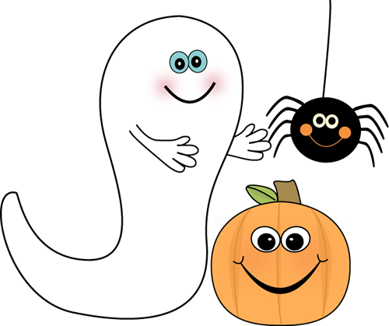

November Spelling Contract
Your goal is to earn points that will go towards classroom coupons. Some activities are worth one point each, while some are worth two points. You must complete one activity per night Monday-Thursday. You also need to complete AT LEAST ONE activity worth two points. Please color in the boxes you have completed, as well as a parent signature for EACH activity completed. Your parent can sign in each box you choose to do. Have fun earning your points. All activities are due on Friday. If your work is completed on paper, complete in homework notebook
One Point Activities

Backwards Words  Write each of your words once normally. Then go back and write your words backwards.  Example:  pilgrim mirglip | Missing Vowels  Write each of your words once and then go back and write your words again. This time, put a dash in place of the vowels.  Example:  grateful gr-t-f-l | Fancy Letters  Write each of your spelling words using fancy letters.  Example:  thanksgiving
Thanksgiving Scene  Draw a picture of a Thanksgiving Scene and hide all of your spelling words in your picture. Don’t forget to make it colorful and detailed. | Telephone Words  Write your words in a list. Then look at a telephone keypad. Translate each letter into the numbers on the keypad. Then write your spelling words in that code.  Example:  stuffing 78833464 | Other Handed  If you are right handed, write your words with your left hand. If you are left handed, write your words with your right hand!
Spelling City  Visit www.spellingcity.com/  jcacaccio/.  Click on the current week’s list. The choose one of the activities to practice your spelling words. | Test Me  Have an adult, babysitter, or older sibling give you a spelling test. Then carefully grade your own answers. | Choo-Choo Words  Write each of your words end-to-end as one long word. Use a different colored pencil for each word.  Example:  pumpkinpilgrimstuffing

Two Point Activities

Thanksgiving Tune  Write a song or poem about the things you are thankful for. Use all of your spelling words and when you are finished, perform it for someone at home. | Guide Words  First, write each of your spelling words on a piece of paper. Then, look up each word in the dictionary. After you find your spelling word, write down the two guide words at the top of the page Repeat for all of your words.
Crossword Spelling  Create a crossword using each of your spelling words. Include across and down clues for each of your words. | Superhero Spelling  Use your spelling words to write a letter to your favorite superhero! You can write one letter using all of your words, as long as your letter makes sense. Or, you can write multiple letters using some of your words until you have used all of your words in a superhero letter.
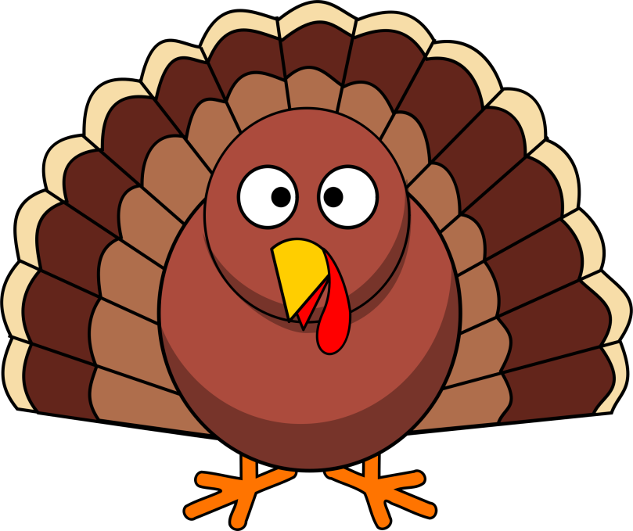

December Spelling Contract
Your goal is to earn points that will go towards classroom coupons. Some activities are worth one point each, while some are worth two points. You must complete one activity per night Monday-Thursday. You also need to complete AT LEAST ONE activity worth two points. Please color in the boxes you have completed, as well as a parent signature for EACH activity completed. Your parent can sign in each box you choose to do. Have fun earning your points. All activities are due on Friday. If your work is completed on paper, complete in homework notebook.
One Point Activities

Upper and Lower  Write your spelling words and then rewrite each word. This time write the vowels in lowercase letters and the consonants in uppercase letters.  Example:  Lower LoWeR | Type ‘Em Up  Type each of your spelling words on the computer. Change the font for each word. | Words Within Words  Write each of your spelling words. Then try to make three new words using the letters of each spelling word.  Example:  Costume  cost met must
Christmas Scene  Draw a picture of a Christmas scene and hide your spelling words in your drawing! Don’t forget to make it colorful and detailed. | Time’s Up!  Set a timer for three minutes. See how many times you can write your words before the timer goes off. Repeat three more times. | Bouncing Words  Say your spelling word. Then bounce a ball while you spell it out loud. Bounce the ball once per letter. Once you have spelled the word, say the word again. Repeat for all your words.
Spelling City  Visit www.spellingcity.com/jcacaccio/.  Click on the current week’s list. The choose one of the activities to practice your spelling words. | Tall Words  Write each of your spelling words in all uppercase letters.  Example:  PUMPKIN | Cheer It Loud  Cheer out your words to someone at home. You can pretend you are a cheerleader or you can think of another fun way to cheer/spell your words out loud.

Two Point Activities

Christmas Story  Write a story about your favorite Christmas memory using all of your spelling words. Remember to organize your writing carefully so your story makes sense to your reader. | Sentence Spelling  Write each of your words in a sentence that shows you understand the meaning. Underline your spelling word in each sentence.  Example:  presents: I save my allowance money so I can buy my family Christmas presents.
Create a Quiz  Create a quiz using your spelling words and include a question for each word. Your questions maybe multiple choice, matching, or true/false. For fun, have someone at home take your quiz and grade them! | Comic Strip Spelling  Use your spelling words to write and illustrate a comic strip. You may use all your spelling words in one comic strip or you may write and illustrate multiple comic strips until all of your spelling words have been used.
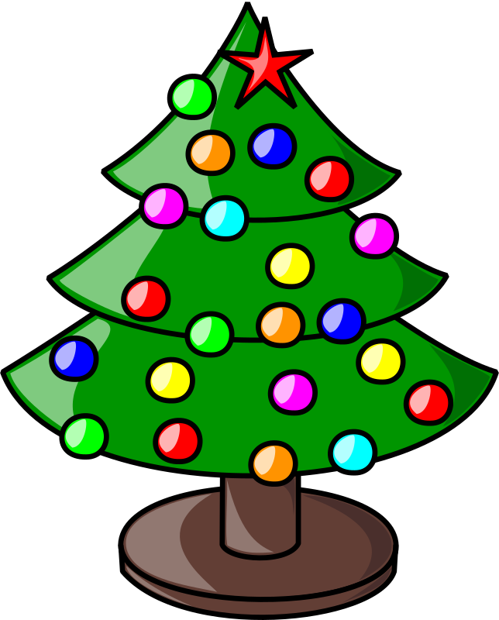

January Spelling Contract
Your goal is to earn points that will go towards classroom coupons. Some activities are worth one point each, while some are worth two points. You must complete one activity per night Monday-Thursday. You also need to complete AT LEAST ONE activity worth two points. Please color in the boxes you have completed, as well as a parent signature for EACH activity completed. Your parent can sign in each box you choose to do. Have fun earning your points. All activities are due on Friday. If your work is completed on paper, complete in homework notebook.
One Point Activities

Other Handed  If you are right handed, write your words with your left hand. If you are left handed, write your words with your right hand! | Missing Consonants  Write each of your spelling words. Then go back and write each of your spelling words again, this time put a dash in place of the consonants.  Example:  snowstorm - -o- - -o- - | Rhyme Time  Write each spelling word. Next to each word, write a word that rhymes with your spelling word. If necessary, your rhyming word can be a nonsense word.  Example:  snow glow
Winter Scene  Draw a picture of a Winter scene and hide your spelling words in your drawing! Don’t forget to make it colorful and detailed. | Buddy Word  Write two spelling word that share a letter and crisscross them at that letter. Do this for all of your spelling words.  s  mitten  o  w | Bubble Words  Write each of your words in bubble letters.  Example:
Spelling City  Visit www.spellingcity.com/jcacaccio/.  Click on the current week’s list. The choose one of the activities to practice your spelling words. | Least to Greatest  Write your words in order from least to greatest, starting with the word that has the fewest letters and ending with the word that has the most. If some of your words have the same number of letters, write them down in ABC order. | In the Air  Write all of your spelling words in the air using your finger. Have someone at home read your words as you write them. You can even take turns writing and reading the words!

Two Point Activities
Guide Words  First, write each of your spelling words on a piece of paper. Then, look up each word in the dictionary. After you find your spelling word, write down the two guide words at the top of the page Repeat for all of your words. | Comic Strip Spelling  Use your spelling words to write and illustrate a comic strip. You may use all your spelling words in one comic strip or you may write and illustrate multiple comic strips until all of your spelling words have been used
Rhyme Time Spelling  Write a short rhyme with each of your spelling words. Underline your spelling word and its rhyming word.  Example:  Sled: I’ve sled so much that I’m tired and need to go to bed. | Friendly Letter  Write a friendly letter to your best friend using your spelling words. You may write one letter using all your spelling words, as long as your letter makes sense. Or, you may write multiple friendly letters until all of your spelling words have been used.

February Spelling Contract
Your goal is to earn points that will go towards classroom coupons. Some activities are worth one point each, while some are worth two points. You must complete one activity per night Monday-Thursday. You also need to complete AT LEAST ONE activity worth two points. Please color in the boxes you have completed, as well as a parent signature for EACH activity completed. Your parent can sign in each box you choose to do. Have fun earning your points. All activities are due on Friday. If your work is completed on paper, complete in homework notebook.
One Point Activities

Conversation Hearts  Make a conversation heart for each of your spelling words. Make sure your conversation hearts are neat and colorful!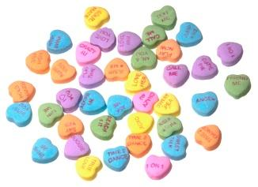 | Rainbow Words  Write each of your words in pencil. Then, trace over your word with a crayon or colored pencil. After that, trace over your words with a different colored crayon or colored pencil. If you trace carefully, you’ll see a rainbow. | Bouncing Words  Say your spelling word. Then bounce a ball while you spell it out loud. Bounce the ball once per letter. Once you have spelled the word, say the word again. Repeat for all your words.
Winter Scene  Draw a picture of a Winter scene and hide your spelling words in your drawing! Don’t forget to make it colorful and detailed. | Pink and Red  Be festive and write your words in pink and red. Write the consonants in pink and the vowels in red. | Bubble Words  Write each of your words in bubble letters.  Example:
Spelling City  Visit www.spellingcity.com/jcacaccio/.  Click on the current week’s list. The choose one of the activities to practice your spelling words. | Backwards Words  Write each of your words once normally. Then go back and write your words backwards.  Example:  heart traeh | Fancy Letters  Write each of your spelling words using fancy letters.  Example:  sweetheart

Two Point Activities

Be Mine, Valentine!  Create valentines using your spelling words! Be creative and include pictures and fun messages with your spelling. Create as many valentines as necessary to use all of your spelling words. | Sentence Spelling  Write each of your words in a sentence that shows you understand the meaning. Underline your spelling word in each sentence.  Example:  envelope: I put my valentine in a special, red envelope.
Riddle Me Spelling  Write a riddle for each of your spelling words. Don’t forget your answers!  Example:  Word: chocolate  I am a sweet treat. I can be dark, milk, or semi-sweet, just to name a few.  What am I?  CHOCOLATE! | Broadcaster Spelling  Pretend you are a news anchor, weather person, or reporter and use your spelling words to write a news report. You may also write multiple news reports that only use some of your words until you have used all of your spelling words in a news story.

March Spelling Contract
Your goal is to earn points that will go towards classroom coupons. Some activities are worth one point each, while some are worth two points. You must complete one activity per night Monday-Thursday. You also need to complete AT LEAST ONE activity worth two points. Please color in the boxes you have completed, as well as a parent signature for EACH activity completed. Your parent can sign in each box you choose to do. Have fun earning your points. All activities are due on Friday. If your work is completed on paper, complete in homework notebook.
One Point Activities

Other Handed  If you are right handed, write your words with your left hand. If you are left handed, write your words with your right hand! | Missing Consonants  Write each of your spelling words. Then go back and write each of your spelling words again, this time put a dash in place of the consonants.  Example:  snowstorm --o---o-- | Rhyme Time  Write each spelling word. Next to each word, write a word that rhymes with your spelling word. If necessary, your rhyming word can be a nonsense word.  Example:  snow glow
Leprechaun Scene  Draw a picture of a St. Patrick’s Day/leprechaun scene and hide your spelling words in your drawing! Don’t forget to make it colorful and detailed. | Buddy Word  Write two spelling words that share a letter and criss-cross them at that letter. Do this for all of your spelling words.  l  u  s h a m r o c k  k | Bubble Words  Write each of your words in bubble letters.  Example:
Spelling City  Visit www.spellingcity.com/jcacaccio/.  Click on the current week’s list. The choose one of the activities to practice your spelling words. | Tall Words  Write each of your spelling words in all uppercase letters.  Example:  SHAMROCK | Cheer It Loud  Cheer out your words to someone at home. You can pretend you are a cheerleader or you can think of another fun way to cheer/spell your words out loud.

Broadcaster Spelling  Two Point Activities  Pretend you are a news anchor, weather person, or reporter and use your spelling words to write a news report. You may also write multiple news reports that only use some of your words until you have used all of your spelling words in a news story. | Comic Strip Spelling  Use your spelling words to write and illustrate a comic strip. You may use all your spelling words in one comic strip or you may write and illustrate multiple comic strips until all of your spelling words have been used.
Create a Quiz  Create a quiz using your spelling words and include a question for each word. Your questions maybe multiple choice, matching, or true/false. For fun, have someone at home take your quiz and grade them! | Guide Words  First, write each of your spelling words on a piece of paper. Then, look up each word in the dictionary. After you find your spelling word, write down the two guide words at the top of the page Repeat for all of your words.
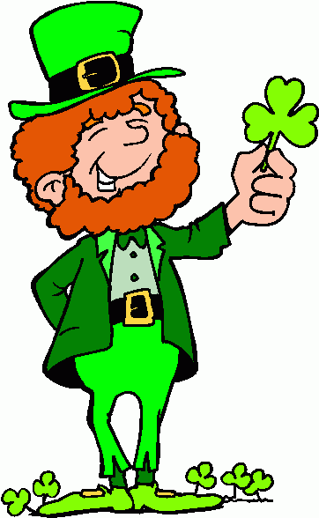

April Spelling Contract
Your goal is to earn points that will go towards classroom coupons. Some activities are worth one point each, while some are worth two points. You must complete one activity per night Monday-Thursday. You also need to complete AT LEAST ONE activity worth two points. Please color in the boxes you have completed, as well as a parent signature for EACH activity completed. Your parent can sign in each box you choose to do. Have fun earning your points. All activities are due on Friday. If your work is completed on paper, complete in homework notebook.
One Point Activities

Scramble Up  Fold your paper in ha long ways, or hot dog style. Then have an adult at home scramble up each of your words on one side of the paper. Then on the other side, try to unscramble your words WITHOUT peeking at your list!  Example:  anr ran | Connect the Dots  Write your spelling words in dots and then connect them by tracing over the dots with colored pencil. | Blue Vowels  Write each spelling word neatly and then go back over and trace each of the vowels with a blue crayon or colored pencil. If you don’t have a blue, just use another color!
Spring Scene  Draw a picture of a spring scene and hide your spelling words in your drawing! Don’t forget to make it colorful and detailed. | Be the Teacher  Give an adult, babysitter, or older sibling a spelling test. Then, carefully grade their answers. | Pyramid Words  Write each of your words in a pyramid shape.  Example:  Spelling word: rain  r  ra  rai  rain
Spelling City  Visit www.spellingcity.com/jcacaccio/.  Click on the current week’s list. The choose one of the activities to practice your spelling words. | Word Fractions  Draw five columns and label them words, total number of vowels, fraction of vowels, number of consonants, and fraction of consonants. Then fill out each column. Example on back of this page. | Cheer It Loud  Cheer out your words to someone at home. You can pretend you are a cheerleader or you can think of another fun way to cheer/spell your words out loud.

Two Point Activities

Riddle Me Spelling  Write a riddle for each of your spelling words. Don’t forget your answers!  Example:  Spelling word→ goose  I fly back north when the weather gets warmer. I make honking noises. What am I?  GOOSE | Springtime Tune  Write a song or poem about the things you like to do in springtime. Use all of your spelling words and when you are finished, perform it for someone at home.
Create a Quiz  Create a quiz using your spelling words and include a question for each word. Your questions maybe multiple choice, matching, or true/false. For fun, have someone at home take your quiz and grade them! | Crossword Spelling  Create a crossword using each of your spelling words. Include across and down clues for each of your words.

WORD FRACTION EXAMPLE:

Words | # of vowels | Fraction of vowels | #of consonants | Fraction of consonants
spring | 1 | 1/6 | 5 | 5/6
flowers | 2 | 2/7 | 5 | 5/7
bloom | 2 | 2/5 | 3 | 3/5

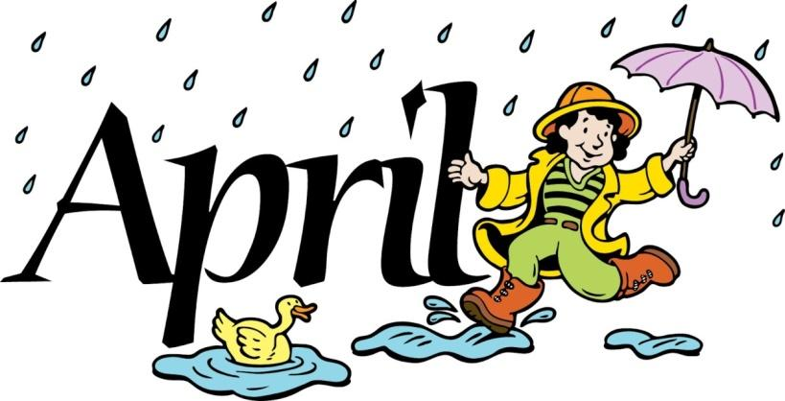

May Spelling Contract
Your goal is to earn points that will go towards classroom coupons. Some activities are worth one point each, while some are worth two points. You must complete one activity per night Monday-Thursday. You also need to complete AT LEAST ONE activity worth two points. Please color in the boxes you have completed, as well as a parent signature for EACH activity completed. Your parent can sign in each box you choose to do. Have fun earning your points. All activities are due on Friday. If your work is completed on paper, complete in homework notebook.
One Point Activities

Other Handed  If you are right handed, write your words with your left hand. If you are left handed, write your words with your right hand! | Type ‘Em Up  Type each of your spelling words on the computer. Change the font for each word. | Sweet or Salty  Have an adult pour sugar or salt on a plate or pan. Then trace your spelling words in the sugar or salt. Erase and repeat for all of your words.
Outdoors Scene  Draw a picture of an outdoors scene and hide your spelling words in your drawing! Don’t forget to make it colorful and detailed. | Telephone Words  Write your words in a list. Then look at a telephone keypad. Translate each letter into the numbers on the keypad. Then write your spelling words in that code.  Example:  flower 356937 | Snap and Clap  Begin by saying your spelling words aloud. Then spell each word out loud letter by letter. When you say a consonant, clap. When you say a vowel, snap. Once you’ve finished spelling the word, say it aloud again.
Spelling City  Visit www.spellingcity.com/jcacaccio/.  Click on the current week’s list. The choose one of the activities to practice your spelling words. | Tall Words  Write each of your spelling words in all uppercase letters.  Example:  FLOWERS | Cheer It Loud  Cheer out your words to someone at home. You can pretend you are a cheerleader or you can think of another fun way to cheer/spell your words out loud.

Two Point Activities
Guide Words  First, write each of your spelling words on a piece of paper. Then, look up each word in the dictionary. After you find your spelling word, write down the two guide words at the top of the page Repeat for all of your words. | Destination Spelling  Pretend you went on an exciting vacation and send a postcard to your best friend. Your postcard should have a picture on the front and a paragraph using your spelling words about your trip on the back. You can write one postcard or you may write multiple postcards using some of your words until all your spelling words have been used.
Comic Strip Spelling  Use your spelling words to write and illustrate a comic strip. You may use all your spelling words in one comic strip or you may write and illustrate multiple comic strips until all of your spelling words have been used. | Interview Time  Write questions for your favorite celebrity with your spelling words. You can include more than one spelling word in each question, but all of them must be used. For fun, try to answer some of the questions you wrote by pretending to be your favorite celebrity.

